In Memoriam Professor Zhu Nankang
1944 - 2023

Professor Zhu Nankang, an old friend of the International Irradiation Association (iia), passed away on 25 December 2023.

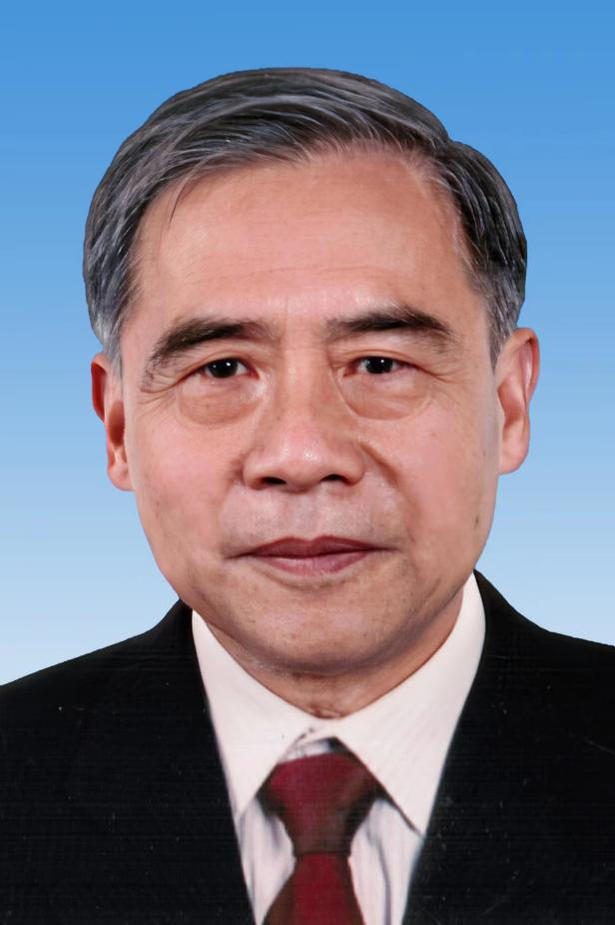

Professor Zhu Nankang is undoubtedly one of the most well-known figures in China's radiation processing industry. He tirelessly promoted the research and development and industrialization of radiation processing in his country and abroad.
He was born in Jiangsu Province in 1944. From 1961 to 1966 he studied for his bachelor’s degree in Engineering Chemistry at Tsinghua University. After graduation, he went to work at the Northwest Nuclear Factory. In 1979, he was transferred to Soochow University (formerly Suzhou Medical College) where he was a professor and served as the dean of the Radiology Department and the vice President of Suzhou Medical College.
In 1994, he worked as a senior visiting scholar in Takasaki Radiation Chemistry Research Institute in Japan. He served as the general manager of Suzhou CNNC Huadong Radiation Technology Co., Ltd. and the director of the Institute of Radiation Technology of Soochow University. He had a history of creating "national first’s" in the Chinese radiation industry: the first to establish the radiation sterilization standard of domestic medical devices; the first to build the automatic conveyor system for gamma irradiators; the first to get the TUV quality system certification and the American FDA to help the medical care products enter the European and American markets; the first to establish the base with 6 million Curie gamma radiation plant; the first to build the domestic radiation vulcanization device and obtain the technical assistance from International Atomic Energy Agency and the finance support from National Development and Reform Commission.
Since 2009, Professor Zhu Nankang has been serving as the expert consultant of CGN Dasheng Accelerator Technology Co., Ltd. His role included: leading the implementation of the first high-power electron accelerator RHODOTRON project introduced by domestic enterprise; the preparation of the establishment of Dasheng Testing Technology Co., Ltd., and getting the CNAS accreditation laboratory certification; guiding the company's development strategy, scientific research plan, international business planning, and introduction and training of talents; and supporting CGN Dasheng Company to grow into one of the largest industrial electron accelerator manufacturers in China.
He has obtained 11 patents, edited and participated in the compilation of 4 works, and published more than 40 papers in well-known journals.
Professor Zhu Nankang has played an active role in the China Isotope and Radiation Association (CIRA) and has served as the vice president of CIRA. For his contributions to the Association, he was awarded the Outstanding Achievement Award of the Association for his contributions to the development of Nuclear technology in China in 2018. He advocated the establishment of the Yangtze River Delta Radiation Association as the president and successfully held the 17th annual meeting, which greatly promoted the vigorous development of the radiation industry in the Yangtze River Delta region. During his tenure as general manager, Suzhou CNNC Huadong Radiation Technology Co., Ltd. became the first iia member in mainland China, and was of the main promoters of the 17th IMRP in Shanghai in 2013. He has participated in many international radiation processing conferences, and actively publicized the information obtained from the conferences in China.

